Task 3: Multi-Table JOINs and Menu Summary View
Q1).Create two tables: restaurants (restaurant_id, name, city) and menu_items (item_id, restaurant_id, item_name, price, category). Link them with a FOREIGN KEY on restaurant_id.
Query:-
create table restaurants(restaurant_id int primary key auto_increment,name varchar(30),city varchar(30));
create table menu_items(item_id int primary key auto_increment ,restaurant_id int ,item_name varchar(30),price int ,category varchar(30),foreign key(restaurant_id) references restaurants(restaurant_id));
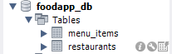
Q2).Insert at least 5 restaurants and 12 menu items; at least one restaurant must have no menu items.
Query:-
INSERT INTO restaurants (name, city)
VALUES
('Spice Garden', 'Surat'),('Food Corner', 'Mumbai'),('Tasty Bites', 'Delhi'),('Royal Kitchen', 'Ahmedabad'),('Green Leaf', 'Pune');
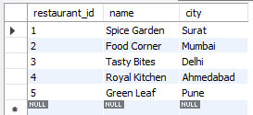
INSERT INTO menu_items
(restaurant_id, item_name, price, category)
VALUES
(1, 'Paneer Tikka', 250, 'Starter'),
(1, 'Butter Naan', 60, 'Bread'),
(1, 'Paneer Butter Masala', 280, 'Main Course'),

(2, 'Veg Burger', 150, 'Burger'),
(2, 'French Fries', 100, 'Sides'),
(2, 'Cold Coffee', 120, 'Beverage'),

(3, 'Chicken Biryani', 300, 'Biryani'),
(3, 'Chicken Tikka', 280, 'Starter'),
(3, 'Mango Lassi', 100, 'Beverage'),

(4, 'Masala Dosa', 180, 'South Indian'),
(4, 'Idli Sambar', 120, 'South Indian'),
(4, 'Medu Vada', 100, 'South Indian');
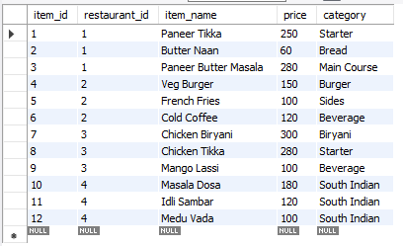
Q3).Write an INNER JOIN query listing restaurant name, item name, and price for all available items.
Query:-
select restaurants.name,menu_items.item_name,menu_items.price from restaurants inner join menu_items on restaurants.restaurant_id=menu_items.restaurant_id;
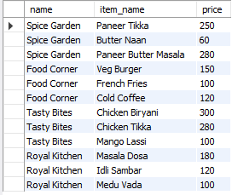
Q4). Write a LEFT JOIN query so that restaurants with no items also appear in results, with NULL values in item columns.
Query:-
select restaurants.name,menu_items.item_name,menu_items.price from restaurants
left join menu_items on restaurants.restaurant_id=menu_items.restaurant_id;
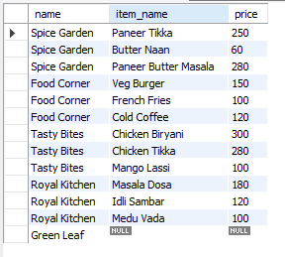
Q5).Create a VIEW named restaurant_menu_summary showing restaurant name, total number of menu items, and average item price grouped by restaurant.
Query:-
create view restaurant_menu_summary as select restaurants.name,count(item_id) as total_num_of_menu_items , avg(price) as avg_price
from restaurants left join menu_items on restaurants.restaurant_id=menu_items.restaurant_id group by restaurants.restaurant_id,restaurants.name; 